**FLUTTER PRACTICE PROBLEMS**

Dr. OSMAN KHALID

<http://osman.pakproject.com>

**LAST UPDATED: 03 June 2024**

Table of Contents

DART (CLO-1) 1

FLUTTER WIDGETS (CLO-2) 6

NAVIGATION IN FLUTTER (CLO-3) 23

DATABASE CONNECTIVITY IN FLUTTER (CLO-4) 25

FLUTTER ADVANCED TOPICS (CLO-5) 29

# DART (CLO-1)

**Question A1:**

Write a program that takes as input the command line arguments of types string, integer and decimal value. In case of a string, its length should be displayed, for an integer value, it should be multiplied by 100, and for a decimal value, we need to take its power of 3.

**Question A2:**

Create a list of records, consisting of name and age values. Sort list with respect to name and then with age.

**Question A3:**

Create a list of integers, 10, 20, 30, 40.

Create another list using the first list, such that at its initialization, the new list is initialized like this:

Item 1: 10, Item 2: 20, Item 3: 30, Item 4: 40.

**Question A4:**

Suppose we have a list of 4 integers. You need to sum the elements of the list without using any loops or calling list elements through their indexes.

**Question A5:**

Suppose we have two numbers a=10 and b=20. You need to swap the numbers without using any third temporary variable, or any arithmetic or logical operators.

**Question A6:**

Suppose you have a range of numbers, and their respective grades:

10 – 30, grade E

31 – 50, grade D

51 – 70, grade C

71 – 90, grade B

91 – 100, grade A

Write a switch – case statement, that takes the marks and show the grade.

**Question B7:**

Create a list of Map with the following items:

{"position": 10, "name": "Jawad"},

{"position": 33, "name": "Faisal"},

{"position": 4, "name": "Zahid"},

{"position": 6, "name": "Ali"},

{"position": 9, "name": "Noman"},

{"position": 4, "name": "Ben"},

Sort the list with first with respect to position, and then with respect to name in case the positions are same.

**Question B8:**

Create a list of Map with the following items:

{"name":"Ali", "age":45, "marks":32 },

{"name":"Noman", "age":32, "marks":23 },

{"name":"Faisal", "age":41, "marks":43 },

{"name":"Noman", "age":11, "marks":43 },

{"name":"Faisal", "age":8, "marks":43 },

Print those records whose age is greater than 30 and whose name is either Noman or Faisal

**Question A8:**

Write an example of function definition and function call with named parameters.

**Question B2:**

Write arrow functions for the following equations:

**Question A9:**

Write arrow functions for the following equations:

Z = a 2 + 4.B2 – 8b + 2a

**Question A10:**

Suppose the equation is:

Z = x2 + 4y2 – 8N2

Where N is represented by a separate equation:

N = p2 + q2

Solve ‘Z’ with arrow function, such that you need to define the arrow function N within the body of Z.

**Question A13:**

Given the following list: ['apples', 'bananas', 'oranges'];

Append a string with each element of the list and capitalize each element of list. Use a combination of map and forEach function.

**Question A14:**

Create a small calculator application using typedef functions performing these operations, add, subtract, multiply, and divide.

**Question A15:**

Suppose you have the following array,

List<Map<String, String>> myArray = [

{'name': 'ali', 'age': '45'},

{'name': 'noman', 'age': '34'},

];

Display the key and value of array elements using for and forEach.

**Question A16:**

Suppose we have the following arrays:

var myArray1 = [3, 4, 5]

var myArray2 = [6, 7, 8]

Write code to append the myArray2 into myArray1.

**Question A17:**

Suppose we have an Dart object { 'name': 'Devin', 'hairColor': 'brown' }

Write code to change value of hairColor using spread syntax (…) three dots.

**Question A18:**

Write an example of defining an arrow function within another arrow function.

**Question A19:**

Create a class Person with attributes: id, name, age.

Derive two classes from person, named Student and Teacher.

The extra attributes of Student are cgpa, currently enrolled semester (e.g., FA22 or SP22, etc), admission date.

The extra attributes of Teacher are salary, designation (Lecturer, Assistant Professor, Professor, etc), department, and joining date.

Populate a list of at least 3 records in each class using class objects.

A user should be able to search a student or teacher with the provided ID. You should store objects of Teacher and Student in a list.

Print list of students whose cgpa is greater than 3.7.

**Question A20:**

Given the following list of objects (name, age, marks), you need to write myObjects.where().forEach() function, so that the name, age, and marks of those students are printed on screen whose age is greater than 25 and marks are greater than equal to 50, and name is Alice or Bob

myObjects.add(Student(name: 'Alice', age: 25, marks: 55));

myObjects.add(Student(name: 'Bob', age: 30, marks: 50));

myObjects.add(Student(name: 'Alice', age: 27, marks: 40));

myObjects.add(Student(name: 'Charlie', age: 22, marks: 45));

**Question B1:**

Given the following list of objects, you need to write myObjects.where().forEach() function, so that the name, age, and marks of those students are printed on screen whose age is greater than 30 and name is Noman or Faisal.

Student(name:"Ali", age:45, marks:32 ),

Student(name:"Faisal", age:41, marks:43 ),

Student(name:"Noman", age:11, marks: 43),

Student(name:"Faisal", age:8, marks:43)

# FLUTTER WIDGETS (CLO-2)

**Question C1:**

Make an app in Flutter that shows the following on screen:

To load an image from the assets folder in Flutter, you need to follow a few steps. Let’s make sure everything is set up correctly:

1. **Folder Structure:**
   * Create an assets folder in your project root directory (if it doesn’t already exist).
   * Inside the assets folder, create an images subfolder (or any other name you prefer).
   * Place your image file (banana.jpg) inside the images folder.
2. **Update**pubspec.yaml**:**
   * Open your pubspec.yaml file.
   * Under the flutter section, add the following lines to specify the assets:
   * flutter:
   * assets:
   * - assets/images/
   * Make sure the indentation is correct.
3. **Image Loading:**
   * Now you can load the image using the Image.asset widget.
   * The asset name should be relative to the assets folder. In your case, it’s "assets/images/banana.jpg".

**Question C2:**

Write a flutter app to show the grade of a student for the given marks. The marks are passed as an argument to the constructor of the widget class computing the grade. The computed grade is shown in the Text widget. Here is the grade distribution for different marks ranges:

< 50 --- F

>= 50 and < 60 --- E

>= 60 and < 70 --- D

>= 70 and < 80 --- C

>= 80 and < 90 --- B

>= 90 --- A

**Question C3:**

Use constructor arguments to pass names of students from a Name() widget to an Attendance() widget. The following should be the output by Attendance() widget, where Present or Absent status is randomly generated.

Ali Khan Present

Noman Present

Faisal Absent

Javed Absent

**Question C4:**

Write code to add a button in Flutter. The text showing in the button should be Click Here. When the button is clicked, a Snackbar should be shown with message “hello world”.

**Question C5:**

Write the code of TextFied() widget function.

When a user enters any text in the TextField(), it is also automatically written in another TextField() in capital letters.

**Question C6:**

Write a flutter program in which when a button is clicked, the text of first TextField() is assigned to second TextField()

**Question C7:**

Write a flutter code, so that when the button is clicked, the text “hello world” should be shown in the Text() widget, and the button should be disabled.

**Question C8:**

Create a simple registration page in Flutter asking for user’s email and name. When the user clicks on register button, the information should be shown using Text widgets. If any input is missing, snackbar message should be shown about the missing element. Use TextEditingController() class to get values of TextField().

**Question C9:**

Suppose you have two TextField(), each containing a number, and a button to add the values of the two TextField(). When the button is clicked, the values of the TextField() are added and result should be shown in a Text() widget.

**Question C10:**

The following layout has three number buttons, a plus and equal operator, and a TextField() initialized with a zero “0”.

0

2

+

1

3

=

The user should be able to enter an expression like this: 423+35+223. When the user press the equal button, the answer should be shown in the TextField().

**Question C15:**

Show a list of students, such that :

|  |  |  |
| --- | --- | --- |
| **ID** | **Name** | **CGPA** |
| 1 | Javed | 3.0 |
| 2 | Noman | 2.7 |
| 3 | Ali | 3.7 |
| 4 | Faisal | 3.3 |
| 5 | Shahid | 4.0 |
| 6 | Kamal | 3.1 |
| 7 | Zahid | 2.3 |

The students whose CGPA are in the range between 2 and less than 3 should be shown in bold and red font.

The students whose CGPA are in the range between 3 and less than 3.7 should be shown in blue font without bold

The students whose CGPA are greater than and equal to 3.7 should be shown in italic, bold, and green font.

**Question C35:**

Write code to show the following list using flutter <ListView> widget

[ {name: ‘Ali’, age: 33, city: ‘Karachi’}, {name: ‘Faisal’, age: 20, city: ‘Lahore’}, {name: ‘Noman’, age: 53, city: ‘Karachi’},]

**Question C33:**

We have following record of students:

|  |  |  |
| --- | --- | --- |
| **RegNo** | **Name** | **Marks** |
| 1 | Ali | 80 |
| 2 | Noman | 60 |
| 3 | Faisal | 40 |
| 4 | Javed | 55 |

You need to show the above record map function flutter’s ListView widget. Display a 4th column in the output that displays ‘pass’ if marks are greater than 50 and fail otherwise.

For example:

|  |  |  |  |
| --- | --- | --- | --- |
| **RegNo** | **Name** | **Marks** | **Status** |
| 1 | Ali | 80 | Pass |
| 2 | Noman | 60 | Pass |
| 3 | Faisal | 40 | Fail |
| 4 | Javed | 55 | Pass |

**Question C34:**

You have a layout as given in the following.

The capital of Pakistan is *<TextInput>*

KARACHI

LAHORE

ISLAMABAD

You need to write a “single method” for all the three buttons. The prototype of method is:

function button_Click().

In this method, you need to get the text of the button clicked. If the text is matching with the string “ISLAMABAD”, the <Text> should be assigned value ISLAMABAD, otherwise it remains blank.

**Question D1:**

Write code to show the following list using flutter GridView widget

[ {name: ‘Ali’, age: 33, city: ‘Karachi’}, {name: ‘Faisal’, age: 20, city: ‘Lahore’}, {name: ‘Noman’, age: 53, city: ‘Karachi’},]

**Question C30:**

Given the following design:

0

A

B

C

Range

(1 to 3)

Range

(4 to 6)

Range

(7 to 9)

0

0

Click Here

You need to generate a random number from 1 to 9. If the random number is from 1 to 3, increment by one in text box A, if the random number is from 4 to 6, increment by one in text box B, if the random number is between 7 to 9, increment by one in the text box C. The program should stop executing when any of the text boxes value crosses 5.

**Question C31:**

We want to implement a cricket scoring game machine. It is a competition between 3 three players. Each player has to reach a target score of 20. Each player will play at his turn (when his button is enabled). At one time, the button of one player is enabled whose has current turn. When a player reaches 20, his button should be disabled forever, and the competition will continue between remaining two players. When the second player will win, game will be over, and the players and their final scores and number of turns should be displayed on the screen as Match Summary (see below).

Target: 100

Target: 100

Target: 100

Current Score: 0

Current Score: 0

Current Score: 0

Player 1 Turn

Player 2 Turn

Player 3 Turn

**Player 1**

**Player 2**

**Player 3**

Click a button to a Generate random number from 1 to 6

Turn Number: 0

Turn Number: 0

Turn Number: 0

**Match Summary**

1st : Player 2, Score 101, No of Turns: 20

2nd: Player 1, Score: 105, No of Turns: 23,

3rd, Player 3, Score: 67, No. of turns: 24

(In above, we are first sorting on base of score, and then on base of number of turns).

**Question C32:**

Suppose you want to build a game in which a random value is generated representing fire or wood or water on button click. Another random value representing fire or wood or water is generated for computer on button click. The winner is decided on the following priority: Fire > Wood, Wood > Water, Water > Fire. The player that gets the higher priority value is the winner. If both get same priority value, it is draw. Write the flutter design and code.

fire

Generate user value

**User value**

wood

**Computer value**

**Winner**

user

Generate computer value

**Question C38:**

Suppose you have an <Text> field and two buttons. The first button is labeled as BLUE and the second button is labeled as GREEN. When the BLUE button is clicked, the color of text in <Text> should changed to BLUE, and when GREEN button is clicked, the color of text in <Text> should change to GREEN..

**Question C39:**

RED

GREEN

**BLUE**

BLUE is clicked

Suppose you have a layout like the above. In the below example, the blue button is clicked, and its text size is increased and text color is changed to black.

The buttons are created by using array of color names, and the text in the buttons is shown in upper case. When a button is clicked, the color of the text below is changed and the name of color is shown as shown in the above example. Moreover, the button that is clicked has font weight changed to bold and font size increased to indicate which button is currently clicked.

**Question C11*:**

You need to develop a snakes and ladders game, as shown below:

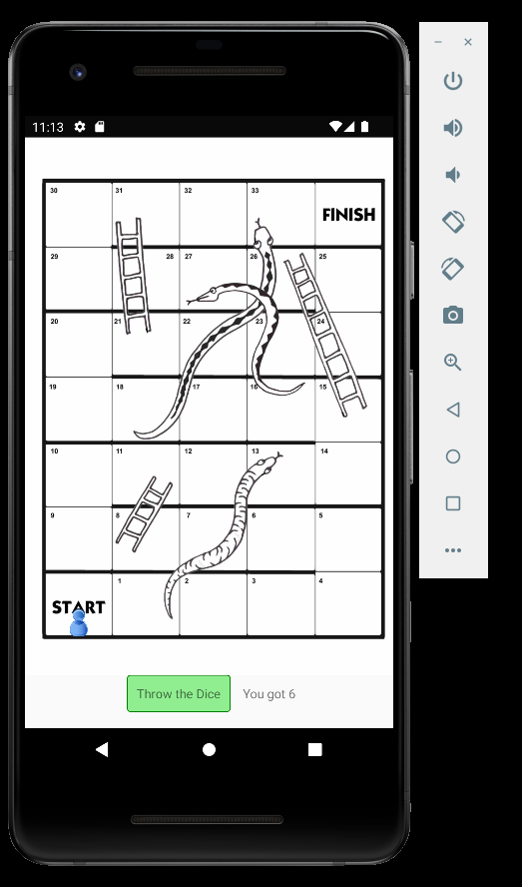

The snakes & ladders board can be downloaded from:

<http://hancockmcdonald.com/sites/hancockmcdonald.com/files/file-downloads/SnakesLaddersBoard.jpg>

The player image can be downloaded from:

http://clipart-library.com/images/kT85jnpXc.png

(NOTE: You may change background board or player images).

The player will promote or demote based on arrival on ladder or snake head respectively. Implement complete logic. The game should end when a player crosses last digit.

**Question C18*:**

You need to create a mobile phone portrait layout:



When the same app is opened in a tablet layout (landscape), it should display like this.

Submit

30 chars max

Email

50 chars max

Name

Gender

Male

Female

Country

Subjects

Phy

Chem

Address

Bio

C++

Java

Javascript

C#

Skills

**Question C41:**

Create a login and a registration page, with proper react native styling. Here is a sample, but your work can be different and better than this.

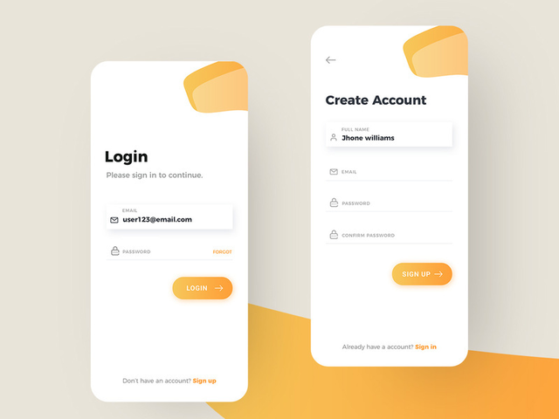

**Question C40:**

Write the following layout.

E-mail

Name

Country

City

Address

**SUBMIT**

When the screen size is reduced, the layout should be changed to:

E-mail

Name

Country

City

Address

SUBMIT

Note that labels are showing “above” the text boxes.

**Question C12*:**

**The following is the website view of Standford university’s computer science department.**

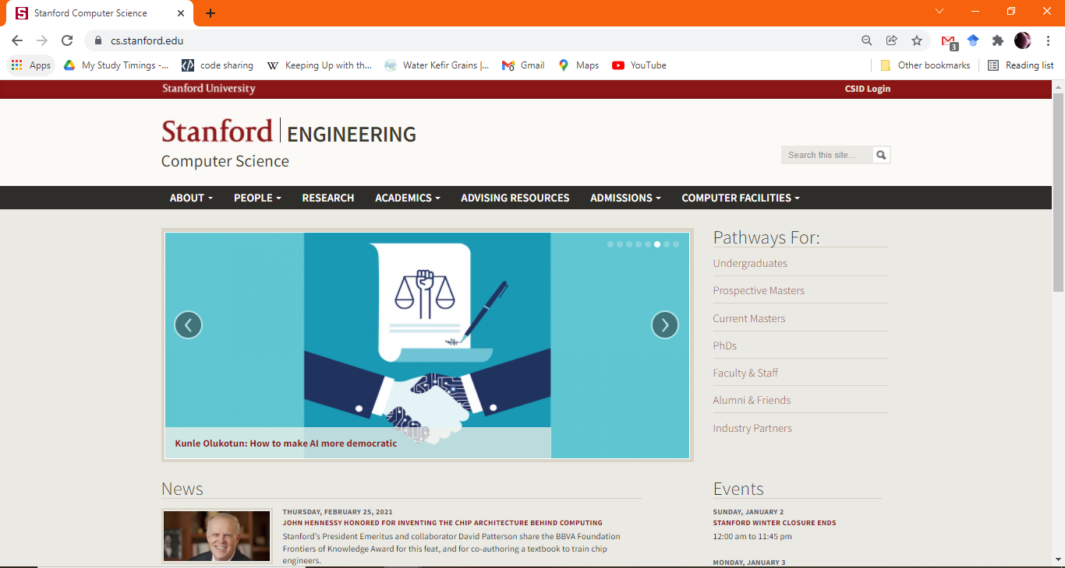

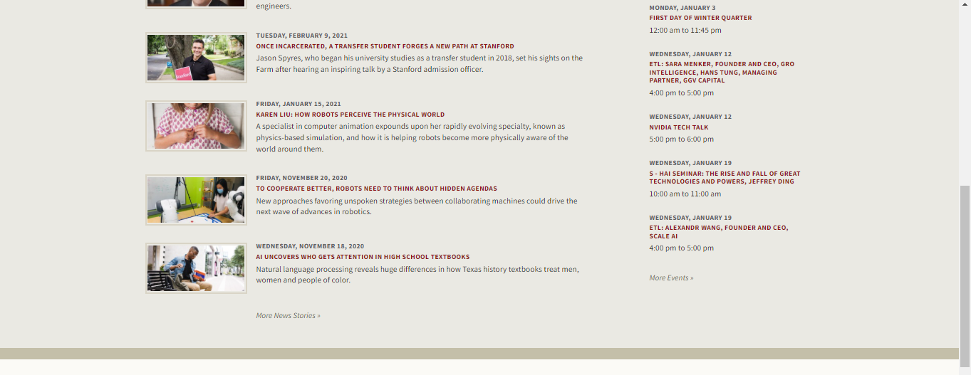



**You need to re-design the above view in mobile layout as follows:**

**You may need to use scrolling.**

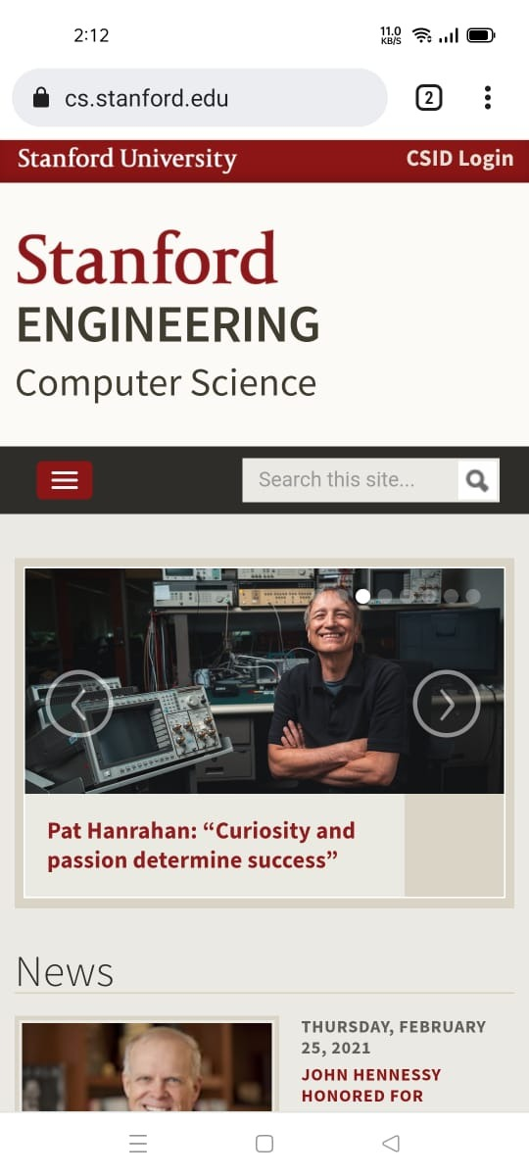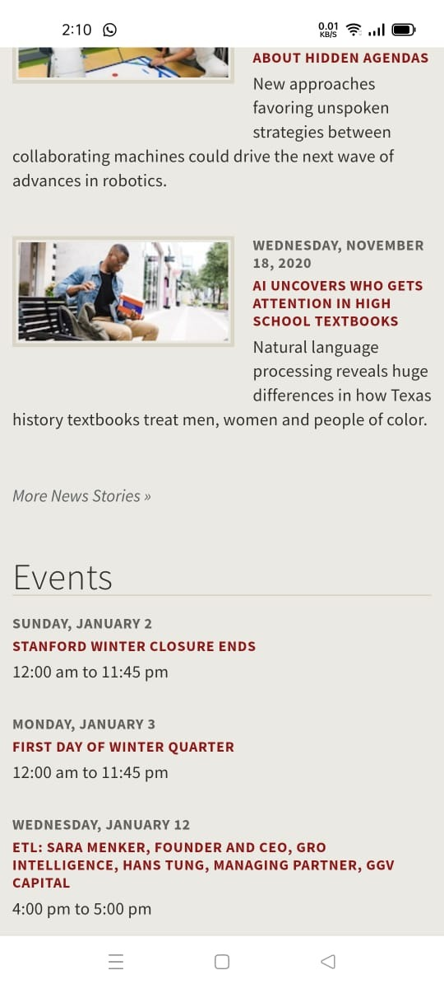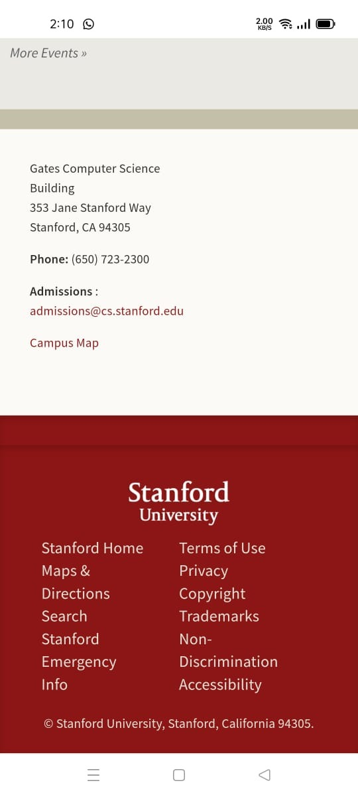

# NAVIGATION IN FLUTTER (CLO-3)

**Question C13:**

Create the following Form

The data is input on the “input screen”.

When the user clicks the submit button, the data is sent to the “display screen” as shown below.

**INPUT SCREEN**

Submit

Email

Name

Gender

Male

Female

Country

Skills

Designing

Backend

Database

Subjects

Phy

Chem

Bio

Address

**DISPLAY SCREEN**

Submit

ali@gmail.com

Email

Ali Khan

Name

Gender

Male

Country

Pakistan

Skills

Designing, Database

Subjects

Phy,

Bio

Address

Lahore, Gulberg

# DATABASE CONNECTIVITY IN FLUTTER (CLO-4)

**Question C17:**

You need to create a mobile application using react native firestore database. Here is the description of the application.

Customer:

A module to contain customers information that can purchase products from the application

Products:

A module of products. Each product can have multiple pictures uploaded to fire store file storage.

Order:

A module that contains orders for various products, the orders are placed by the customers.

Order Details:

A module that contains order id, and information about products purchased by a customer.

You need to:

Develop a customer module where a customer can place various orders. The products should be maintained in a shopping cart. On checkout a textinput will be provided to enter a fake card info.

A seller module where he can add products and can see the orders placed by the customer. The seller should be able to complete the orders as we usually see in e-commerce applications.

**Question C14*:**

Use the tab navigation or drawer navigation to show menu for the assignment.

You need to store and retrieve data from Firestore database.

The user will perform input of data in the following screen. When the submit button is clicked, the data is uploaded in firestore as a new document in the collection “persons”. You may also need subcollections for subjects and skills.

**INPUT DATA SCREEN**

Submit

Email

Name

Gender

Male

Female

Country

Skills

Designing

Backend

Database

Subjects

Phy

Chem

Bio

Address

**DISPLAY ALL DATA SCREEN**

Use flat list or some other list to show the data of all persons, in the following format:

|  |  |  |  |
| --- | --- | --- | --- |
|  | **Email** | **Name** | **Country** |
| Select | ali@gmail.com | Ali Khan | Pakistan |
| Select | noman@gmail.com | Noman Ali | Afghanistan |

When the user click on “select” against any record, the data is displayed in the following manner. (Pass the email to the next screen, where the record will be fetched from firestore against the email and showed in display screen).

**DISPLAY SINGLE DATA**

Edit

ali@gmail.com

Email

Ali Khan

Name

Gender

Male

Country

Pakistan

Skills

Designing, Database

Subjects

Phy,

Bio

Address

Lahore, Gulberg

Delete

When the user press delete button, the record should be deleted (after a confirmation alert) and the user should be directed back to the display all data screen.

When user presses on Edit button, the edit data screen should appear where his name and address should be in edit mode. (again, pass the email to edit screen and fetch record from db)

**UPDATE DATA SCREEN**

Update

ali@gmail.com

Email

Name

Address

Lahore, Gulberg

Back

 Ali Khan

When user clicks on Update, the record is updated. When the user click on Back, he is directed back to the display single data screen.

**SEARCH SCREEN.**

Search

Email

ali@gmail.com

When the user click on search button, the email is passed to the display single data screen, where the user’s record is displayed.

# FLUTTER ADVANCED TOPICS (CLO-5)

**Question C16:**

Take a picture from your mobile using camera SDK, and upload on Firestore database. Also store the name of the person whose picture is taken.